3.4.1 Extension activities in the neighborhood community in terms of impact and sensitizing students to social issues and holistic development during the last five years.
To provide healthy atmosphere in and around the campus and create awareness in the mind of people about social scenarios our Management, Faculty Members, students volunteers, NSS coordinators joined their hands together to impart service and support to the needy people. Social programmes like Swatch Bharat, Education Awareness, Women’s safety, Disaster Management, Medical aid, Research and Innovation, etc., were executed through NSS activities.
- Awareness on open defecation issues was given and toilet was constructed for public utility.
- Education awareness programme were conducted to the rural students. Computer systems were donated and training was provided on software programs to the school students.
- Summer Camps were organized to create Higher education awareness for students studying in neighboring schools.
- Project expo summit was conducted to motivate and encourage the knowledge of school students
- Vigilance Awareness Week was organized in college campus. Nearly1000 students participated and played an active role.
- Medical camp was organized for dermatological issues.
- Gaja Cyclone relief activities were organized by our college NSS volunteers. Grocery items, plastic shelters sheet and solar lights were donated to the Gaja cyclone affected people. Management, Faculty Members, staff members, Alumni and students provided the fund for Gaja Cyclone relief measures.
- National Deworming day was organized.
- Organized CCTV Camera awareness rally jointly with T8 Muthapudupet police station on 07.02.2019. Nearly 130 students participated and raised slogans supporting the installation of CCTV cameras.
- National Voters’ day was celebrated and rally was organized in and around the campus for awareness of General Election.
- Streets were cleaned and unwanted bushes were separated as part of Swatch Bharath Campaign.
- Transport arranged and food for paramedical staff for Polio vaccination for nearby villages.
- Celebration of Independence Day, Republic Day, Constitution Day, Engineers day and Women's Day.
- Awareness on Tree Plantation, Water and Tree Conservation Programme.

CCTV CAMERA AWARENESS RALLY
Aalim Muhammed Salegh college of Engineering and T8 muthapudupet police station jointly organized CCTV camera awareness rally in and around Muthapudupet on 07.02.2019. Our secretary and Correspondent Alhaj S. Segu Jamaludeen, T8 Muthapudupet police Inspector S.Radhakrishnan, Prof. Dr.M.Afzal Ali Baig Principal, Dr.K.Suresh Kumar., NSS Programme Officer, Mr.D.Ravindran., Ex VAO Palavedu Village, Staff members and 130 student volunteers have participated, raising slogans supporting installation and importance of CCTV.

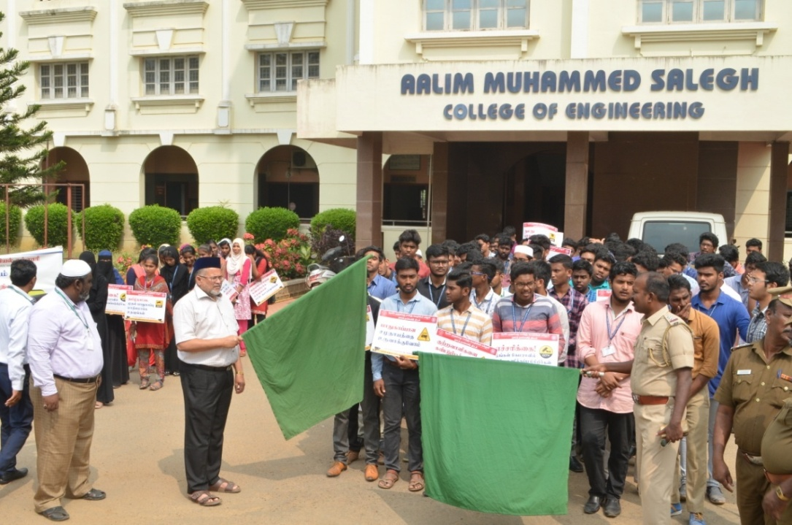
Our secretary and Correspondent Alhaj S. Segu Jamaludeen Flag off the Rally
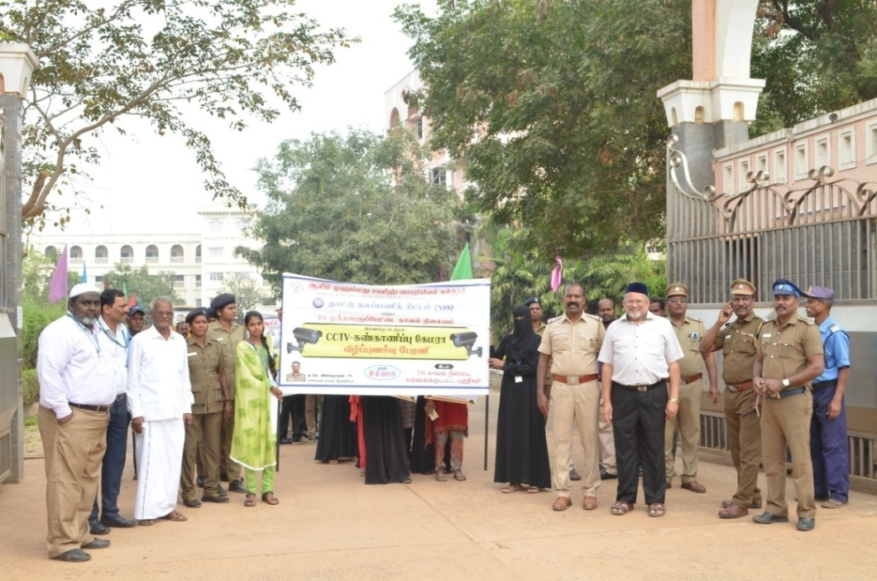
Our secretary and Correspondent Alhaj S. Segu Jamaludeen, T8 Muthapudupet police Inspector S.Radhakrishnan, Prof. Dr.M.Afzal Ali Baig Principal, Dr.K.Suresh Kumar., NSS Programme Officer, Mr.D.Ravindran ExVAO,

GAJA CYCLONE RELIEF Dec-2018
Gaja cyclone is the most devastating in the delta region of Tamil nadu. College management has decided to do relief in big scale for the people of Delta region in hand. In this faculty‘s half day salary is donated and students contribution is added to get the relief materials. Materials like grocery, plastic shelters, and solar lights were purchased and given to the needy people in the delta region. In the relief programme Mr. K.Pandiarajan Hon’ble Minister of Tamil Language and Tamil Culture, Our Secretary & Correspondent of Aalim Muhammed Salegh Group of Institutions, Alhaj. Athullah,Trustee & Administrator, Prof. Dr.M.Afzal Ali Baig., Principal, Dr.K.Suresh Kumar., NSS Programme Officer staff members and public have present. Nearly 10 volunteers and 4 faculty members have gone to the delta region and given the aid to the needy people in hand.
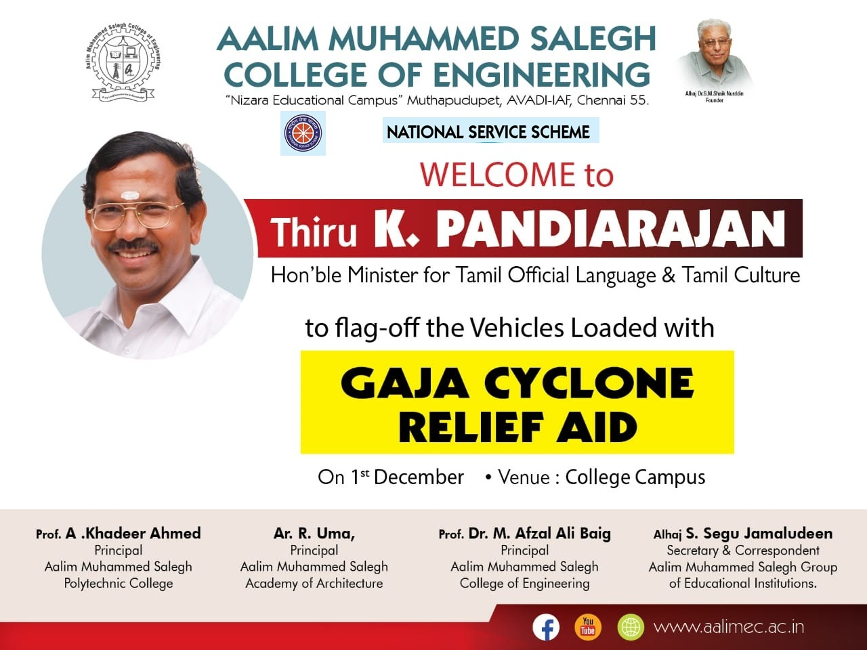

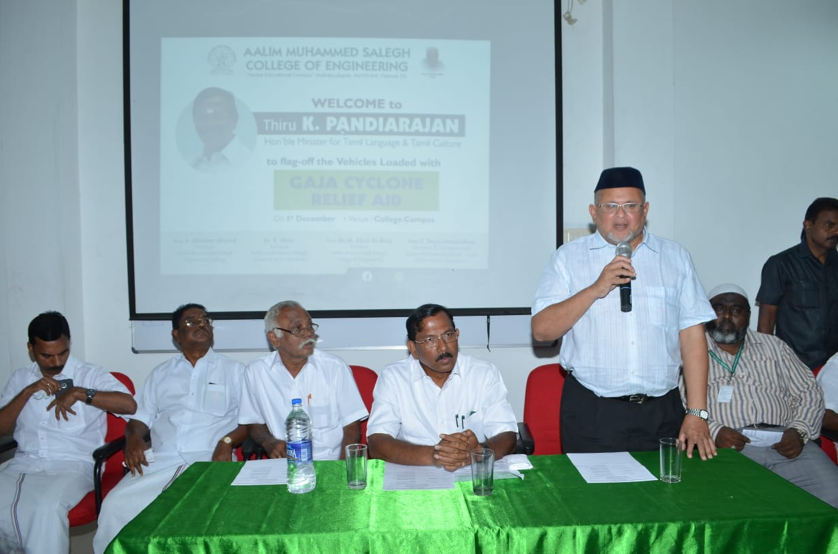 | 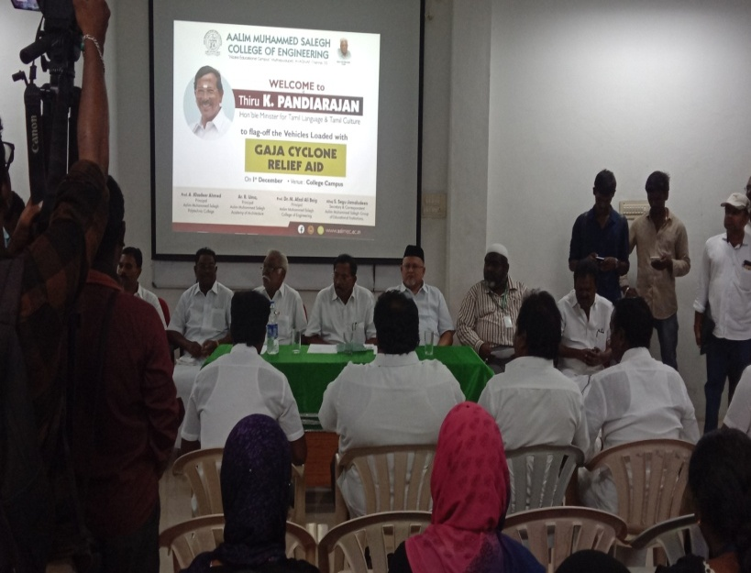
Secretary & Correspomdent Alhaj S. Segu Jamaludeen, Trustee Administrator Alhaj Athullah, Mr. K.Pandiarajan Hon’ble Minister of Tamil Language and Tamil Culture., Prof. Dr.M.Afzal Ali Baig Principal, Dr.K.Suresh Kumar., NSS Programme Officer, Staff Members
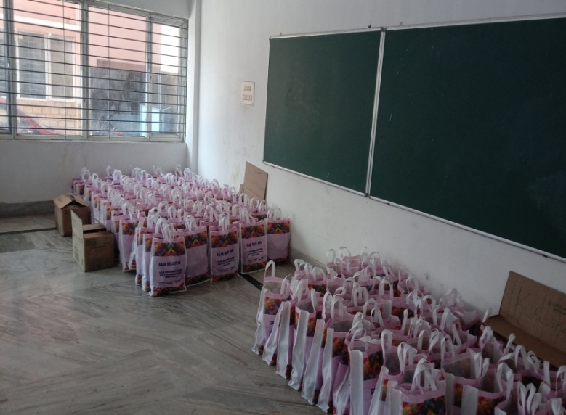 | 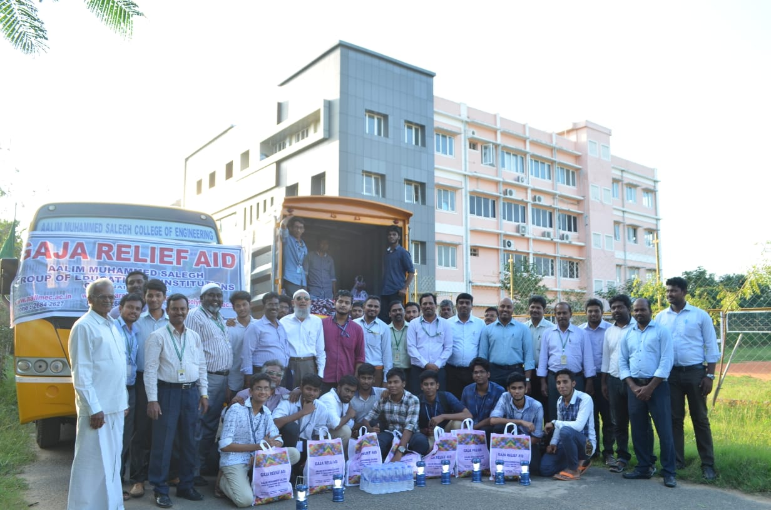

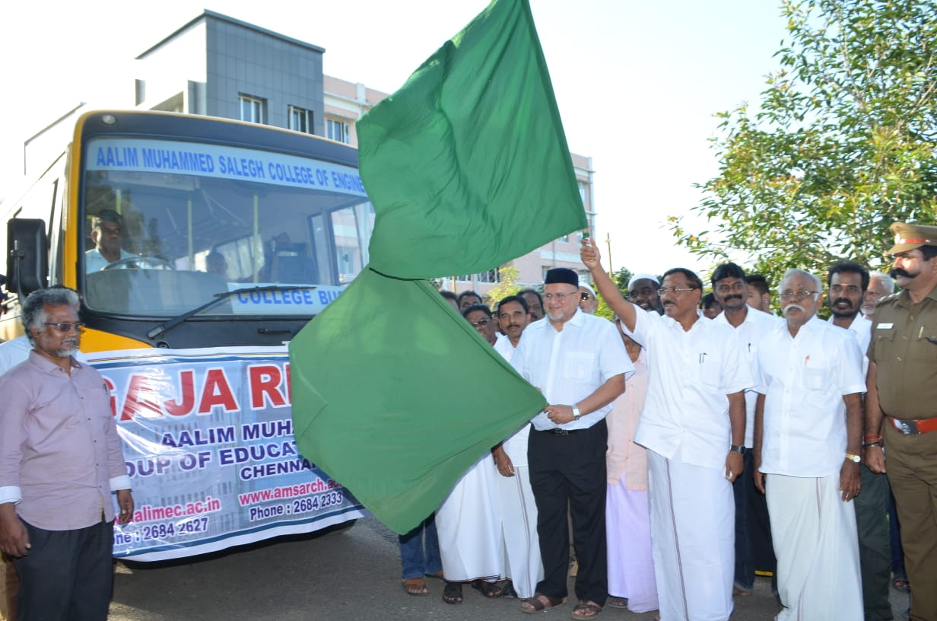 | 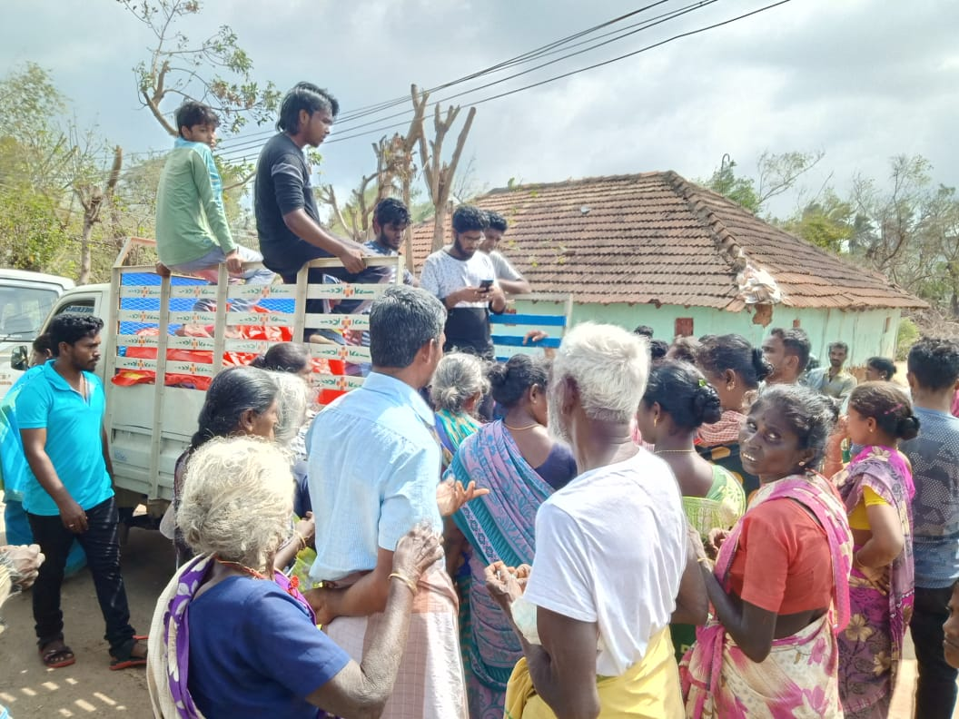

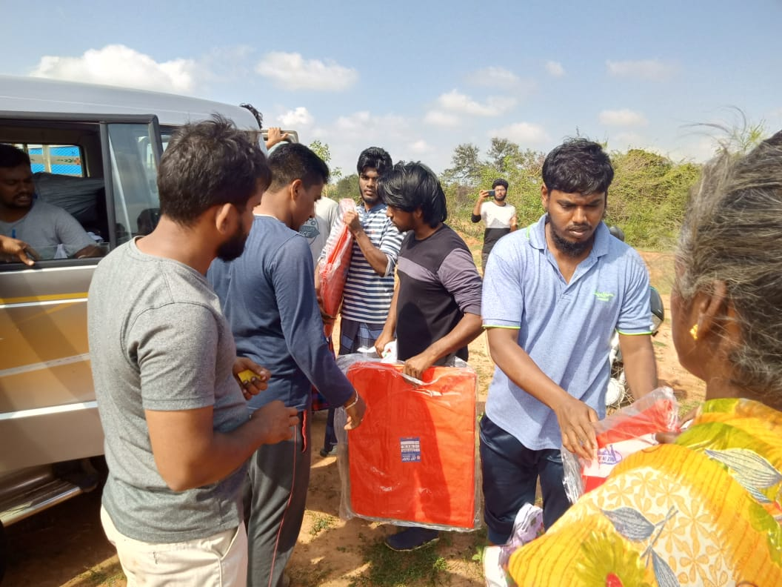 | 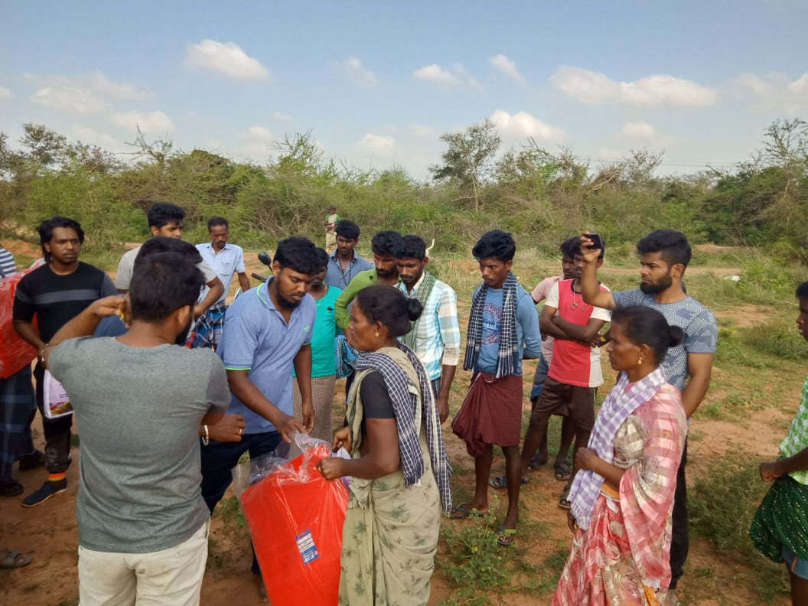
Materials like grocery, plastic shelters, and solar lights were given to the needy people in the delta region By our Staff members and NSS Volunters

SWAACH BHARAT SUMMER INTERNSHIP(SBSI) PROGRAMME 2018
Inauguration of Two toilet with attach bathrooms at Palavedu village, thiruvallur district on 28.11.2018, constructed by the 40 NSS volunteers under swaach bharat summer internship programme 2018. Avadi Municipality comminssioner Mr.M.Jothikumar as a chief Guest for the opening ceremony. SBSI certificates were issued to the volunteers. Prof. Dr.M.Afzal Ali Baig ., Principal, Alhaj Athaullah,Trustee & Administrator, .K.Suresh Kumar., NSS Programme Officer, Staff Members Mr.Ravindran Naidu Ex VAO Palavedu Village and nearly 50 villagers have participated.
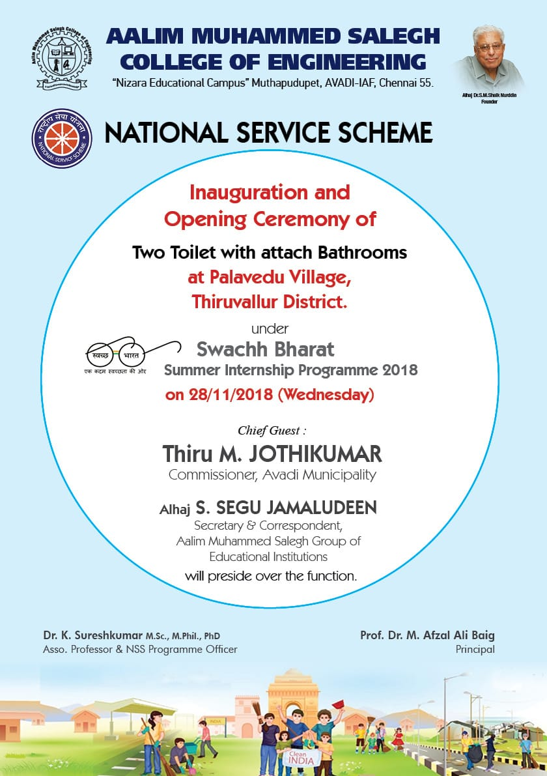

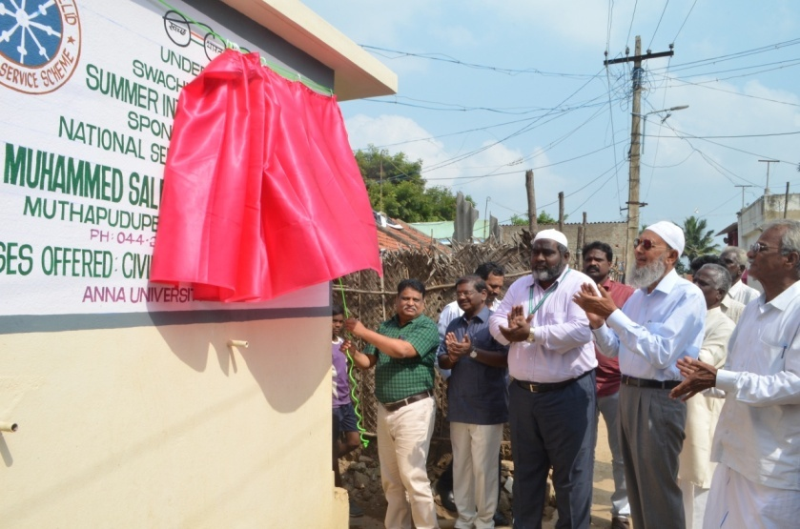 | 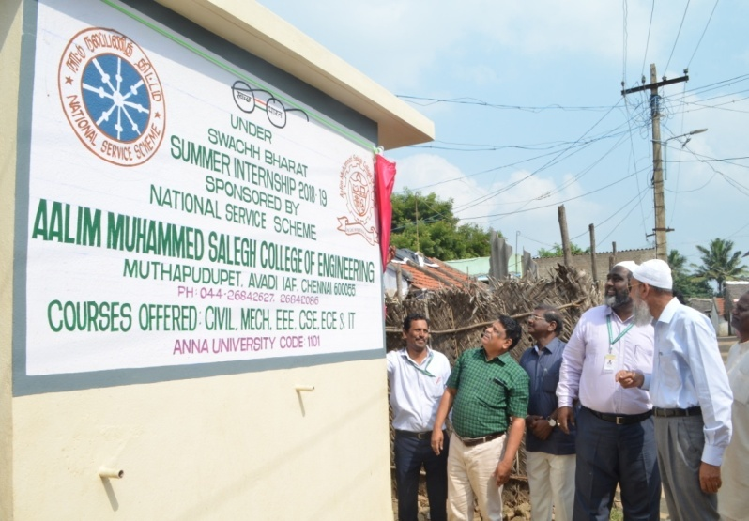
Mr.M.Jothikumar., Avadi Municipality comminssioner Inaugurated the two toilets. Prof. Dr.M.Afzal Ali Baig ., Principal, Alhaj Athaullah,Trustee & Administrator, .K.Suresh Kumar., NSS Programme Officer, Staff Members Mr.Ravindran Naidu Ex VAO Palavedu Village and Villagers

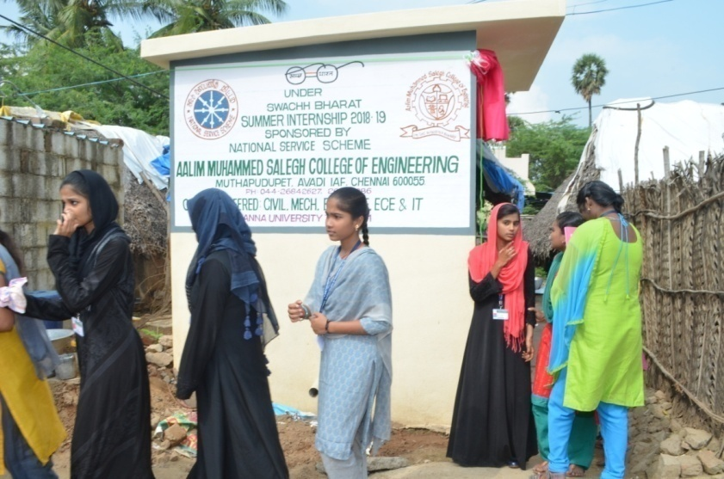 | 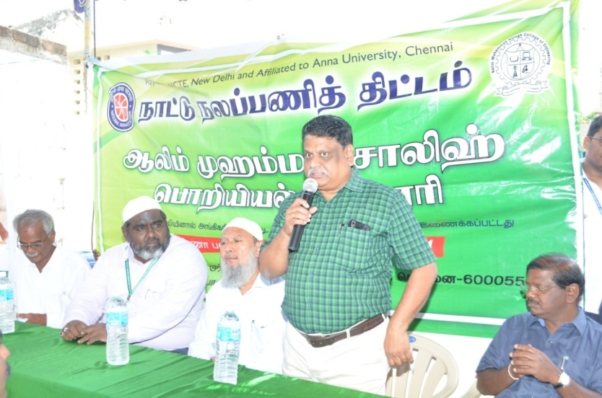

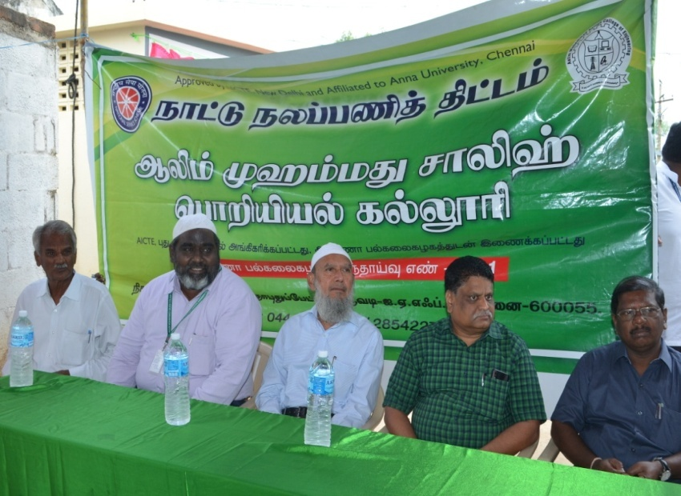 | 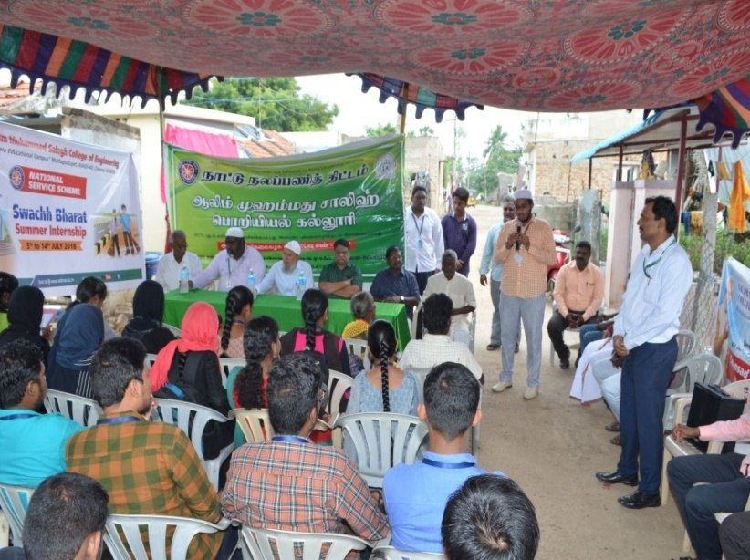

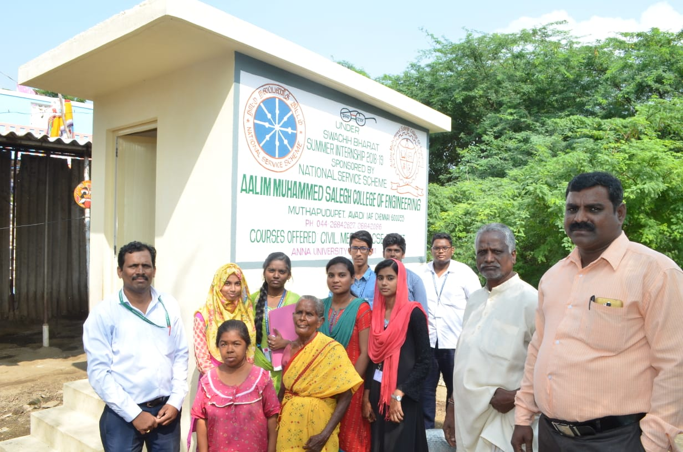 | 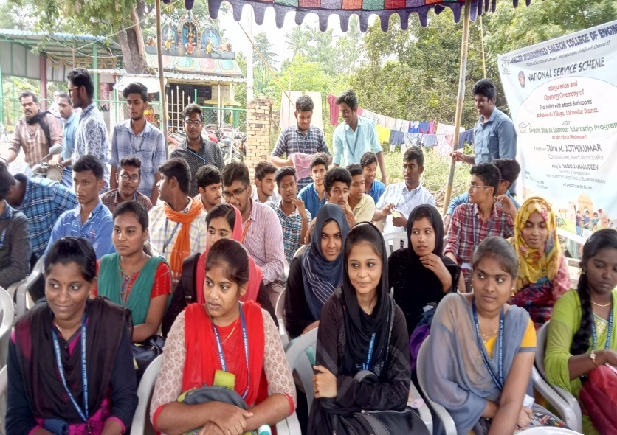

K.Suresh Kumar., NSS Programme Officer, Staff Members Mr.Ravindran Naidu Ex VAO Palavedu Village, NSS Volunteers and Villagers
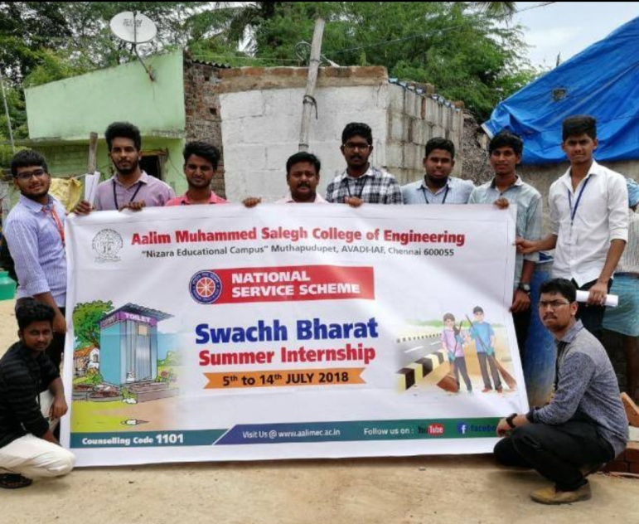 | 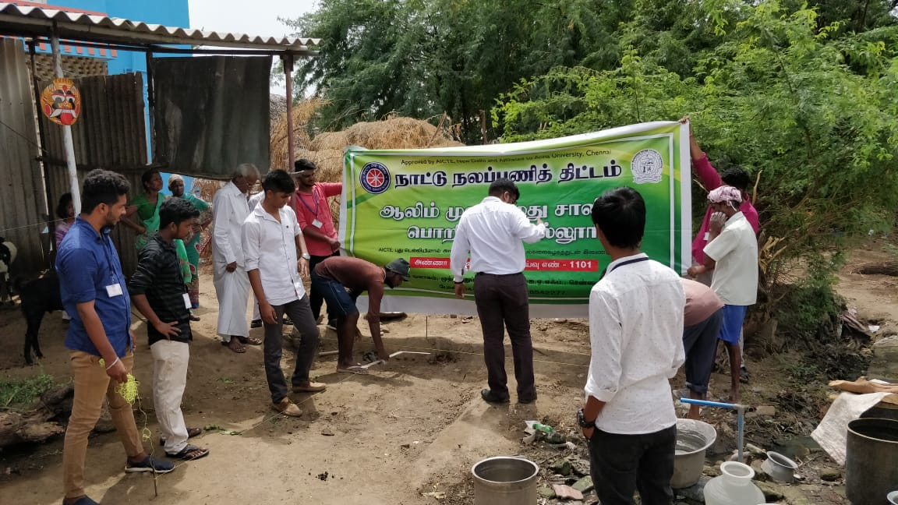
NSS Voulnteers in the Swachh Bharat summer internship (SBSI) programme
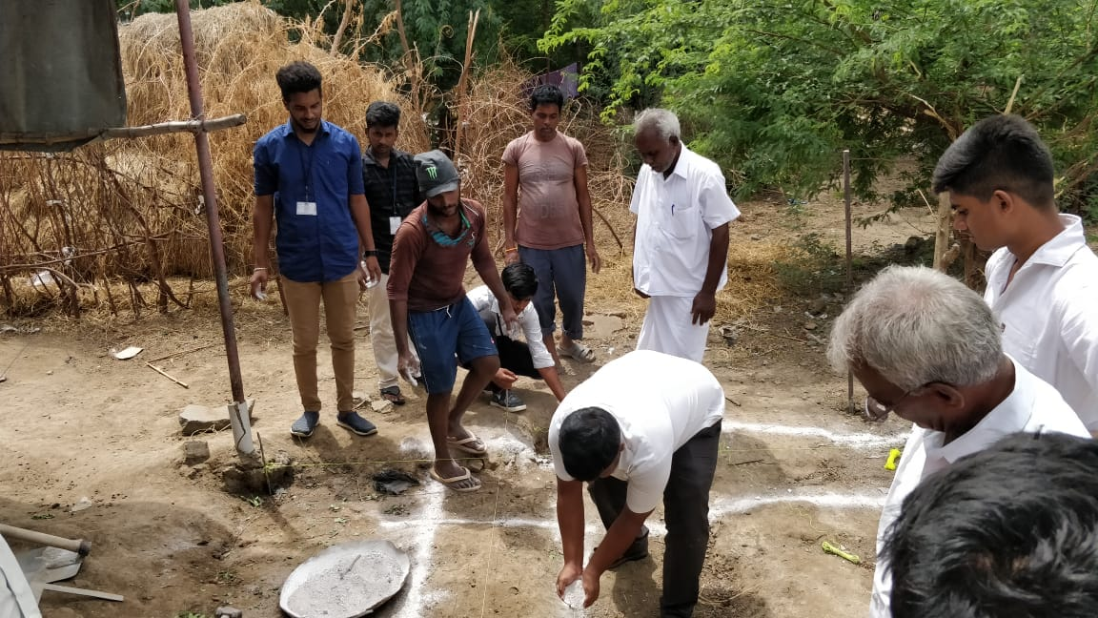 | 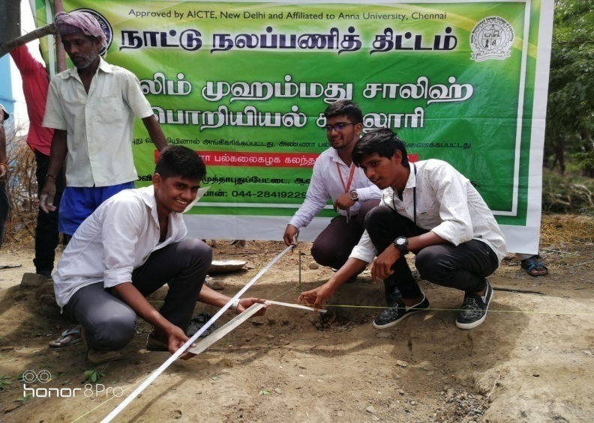
NSS Voulnteers in the Swachh Bharat summer internship (SBSI) programme

